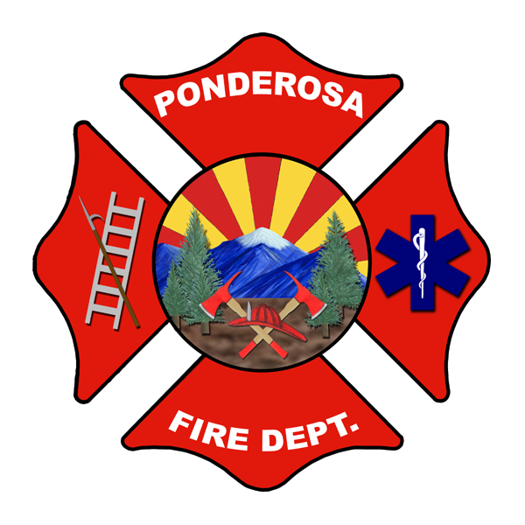
PONDEROSA FIRE DISTRICT
Admin Office: 11951 W. Shadow Mountain Drive
Bellemont, AZ 86015
Phone: 928-773-8933 Fax 928-773-8927
Email: office@ponderosafire.org
Website: www.ponderosafire.org

2021-22 FY Board of Directors Regular Meeting Schedule

July 15, 2021 | Station 82, Bellemont/ Zoom
August 19, 2021 | Station 82, Bellemont/ Zoom
September 16, 2021 | Station 82, Bellemont/ Zoom
October 21, 2021 | Station 82, Bellemont/ Zoom
November 18, 2021 | Station 82, Bellemont/ Zoom
December 16, 2021 | Station 82, Bellemont/ Zoom
January 20, 2022 | Station 82, Bellemont/ Zoom
February 17, 2022 | Station 82, Bellemont/ Zoom
March 17, 2022 | Station 82, Bellemont/ Zoom
April 14, 2022 | Station 82, Bellemont/ Zoom
May 19, 2022 | Station 82, Bellemont/ Zoom
June 16, 2022 | Station 82, Bellemont/ Zoom

The Regular Monthly Meetings of the Ponderosa Fire District Governing Board, which are open to the public, will be held on the above dates and at the locations listed unless otherwise posted 24 hours prior to the meeting date in accordance with A.R.S § 38-431 through 431.09. Ponderosa Fire District’s official posting places are Fire Station 81 in Parks at 1511 Spring Valley Road and Fire Station 82 in Bellemont at 11951 W. Shadow Mountain Drive and the www.Ponderosafire.org website.

Meeting Agendas will be available 24 hours prior to each meeting and can be picked up at the Fire Station #82 in Bellemont at 11951 W. Shadow Mountain Drive, faxed, or by emailing office@ponderosafire.org.

Zoom Link: Join Zoom Meeting
https://zoom.us/j/98285510180
Meeting ID: 982 8551 0180

In the event an Emergency or Special Meeting must be called with less than 24 hours notice, a notice, agenda and minutes of that meeting will be posted within 24 hours after the meeting per A.R.S § 38-431.02(D).

Pursuant to A.R.S § 38-431.03.A, the Governing Board may vote to go into Executive Session, which is closed to the public, during a Regular, Special or Emergency Meeting.

