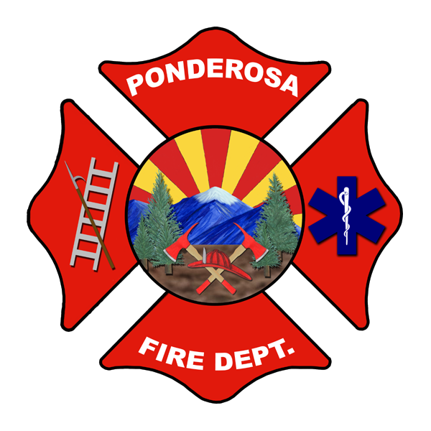
PONDEROSA FIRE DISTRICT
11951 Shadow Mountain Drive
PO Box 16359
Bellemont, AZ 86015
Phone: 928-773-8933 Fax: 928-773-8927
NOTICE OF PUBLIC HEARING
SPECIAL BOARD MEETING OF THE PONDEROSA FIRE DISTRICT GOVERNING BOARD

Notice is hereby given to members of the Ponderosa Fire District (PFD) Board of Directors and to the general public that the PFD Governing Board will meet on Monday, March 7, 2022, at 6:00 p.m. at Ponderosa Fire Station #82, 11951 W. Shadow Mountain Drive Bellemont, AZ 86015 for a Regular Board Meeting pursuant to A.R.S. § 38-431.02 which is open to the public. Members of the PFD Board may attend either in person or by telephone. Persons with disability may request a reasonable accommodation by contacting the Administrative Office at 928-773-8933 at least 24 hours prior to meeting time. The Board may vote to go into an Executive Session on any agenda item, which will not be open to the public, pursuant to A.R.S. § 38-431.03(A)(3) for legal advice with the Fire District Attorney on the matter(s) set forth in the agenda. ALL ITEMS ARE SET FOR POSSIBLE ACTION.
AGENDA

- CALL TO ORDER/ROLL CALL
Mark Christian, Chairman Kurt Wildermuth, Vice-Chairman
Thomas Humphrey, Clerk Rick Tomjack, Member

Lee Antonides, Fire Chief

- PLEDGE OF ALLEGIANCE

- CALL TO THE PUBLIC
Pursuant to A.R.S. § 38-431.01(H), the Board of Directors may make an open call to the public during a public meeting, subject to reasonable time, place and manner restrictions, to allow individuals to address the Board on any issue within the jurisdiction of the Board. At the conclusion of an open call to the public, individual members of the Board may respond to criticism made by those who have addressed the Board, may ask staff to review a matter or may ask that a matter be put on a future agenda. However, members of the Board shall not discuss or take legal action on matters raised during an open call to the public unless the matters are properly noticed for discussion and legal action. If the item is an agenda item, please wait until a motion is made and seconded and after Board members have had the opportunity to discuss the motion. The public may then be recognized to speak before the Board takes a vote. All remarks should be addressed to the Board. Any member of the public desiring to address the Board must first be recognized by the Chairman, come forward, state their name and address in an audible tone for the record and shall limit their remarks to not longer than (5) minutes. A maximum of 15 minutes total has been allocated to this agenda item.

- NEW BUSINESS
  - Discussion and possible action regarding the sale of water tender 82 (WT82)
  - Discussion and possible action regarding the sale of engine 821 (E821)
  - Discussion and possible action regarding the purchase of used, refurbished Type 1 engine
  - Discussion and possible action regarding financing options for the purchase of the used, refurbished type 1 engine

- ADJOURNMENT
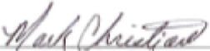
Mark Christian, Board Chairman

